LAB 1 Exercises

- Basic: Create a Car class with fields brand, year and mileage, and a method display(). Create three cars and print them.
Code
import java.time.Year;
public class Car {
String brand;
Year year;
int mileage;
// the method for displaying
void display(){
System.out.println(this.brand+" "+ this.year+" "+this.mileage);
}
public static void main(String[] args){
// creating 3 Cars
Car lambo = new Car();
Car cruiser = new Car();
Car gd6 = new Car();
// assigning the cars
lambo.brand="lamboghini";
lambo.year= Year.of(2026);
lambo.mileage=200398;
cruiser.brand="Cruiser Mhani";
cruiser.year= Year.of(2023);
cruiser.mileage=2789;
gd6.brand="Toyota hilux";
gd6.year= Year.of(2000);
gd6.mileage=102;
// displaying the car's information or details
lambo.display();
cruiser.display();
gd6.display();
}
}

output
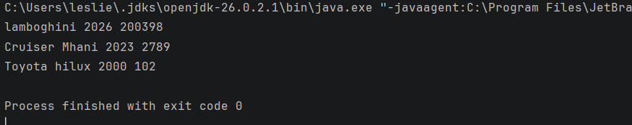

- Basic: Add a method isAntique() to Car that returns true when the car is more than 25 years old.
Code

import java.time.Year;
public class Car {
String brand;
Year year;
int mileage;
// the method for displaying
void display(){
System.out.println(this.brand+" "+ this.year+" "+this.mileage);
}
// this method is for checking if the car is antique or not
boolean isAntiue(){
// we check if the this year or current year minus the car's year it was built is greater than 25
if (25 < (Year.now().getValue() - this.year.getValue())){
// if it is greater we return true
return true;
}
// if not its false
return false;
}
public static void main(String[] args){
// creating 3 Cars
Car lambo = new Car();
Car cruiser = new Car();
Car gd6 = new Car();
// assigning the cars
lambo.brand="lamboghini";
lambo.year= Year.of(2026);
lambo.mileage=200398;
cruiser.brand="Cruiser Mhani";
cruiser.year= Year.of(2023);
cruiser.mileage=2789;
gd6.brand="Toyota hilux";
gd6.year= Year.of(2000);
gd6.mileage=102;
// displaying the car's information or details
lambo.display();
System.out.println(lambo.isAntiue());
cruiser.display();
System.out.println(cruiser.isAntiue());
gd6.display();
System.out.println(gd6.isAntiue());
}
}
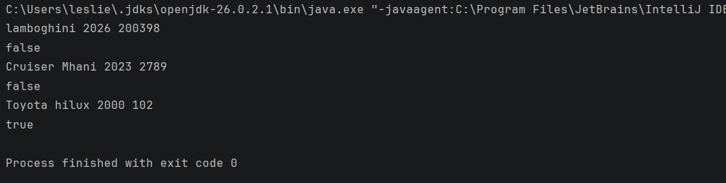
output

- Intermediate: Write a Rectangle class with width, height, and methods area() and perimeter(). Create an array of 5 rectangles and print the one with the largest area.
Code

public class Rectangle {
double width;
double height;
// creating a constructor for the rectangle
Rectangle(double width, double height){
this.width = width;
this.height = height;
}
// a method that returns area just multiplying height and width
double area(){
return (width * height);
}
// a method that returns the perimeter just multiplying the sum of height and with by 2
double perimeter(){
return (2*(width + height));
}
public static void main(String[] args){
// creating the rectangle
Rectangle r1 = new Rectangle(4,3);
// printing the area and perimeter of the rectangle
System.out.println("the area is "+r1.area()+", the perimeter is "+ r1.perimeter());
// creating the array of 5 rectangle
Rectangle[] rectangles = new Rectangle[5];
rectangles[0] = new Rectangle(2,3);
rectangles[1] = new Rectangle(3,3);
rectangles[2] = new Rectangle(4,3);
rectangles[3] = new Rectangle(5,3);
rectangles[4] = new Rectangle(1,3);
// we make the first rectangle in the array the largest
Rectangle largest = rectangles[0];
// using a for loop to compare the largest with every other rectangle in the array
for (int i = 0; i < 4; i++){
if (largest.area() < rectangles[i].area()){
largest = rectangles[i];
}
}
System.out.println("the largest has an area of " + largest.area());
}
}

Output
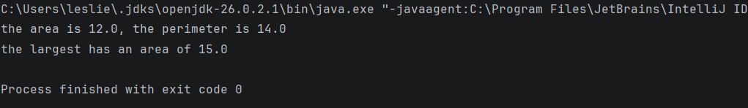

- Intermediate: Predict, then run, a program that assigns Rectangle r2 = r1;, changes r2.width, and prints r1.width. Explain the result in your lab record.
Code
public class Rectangle {
double width;
double height;
// creating a constructor for the rectangle
Rectangle(double width, double height){
this.width = width;
this.height = height;
}
// a method that returns area just multiplying height and width
double area(){
return (width * height);
}
// a method that returns the perimeter just multiplying the sum of height and with by 2
double perimeter(){
return (2*(width + height));
}
public static void main(String[] args){
// creating the rectangle
Rectangle r1 = new Rectangle(4,3);
Rectangle r2 = r1;
// now lets print width of r1 and r2
System.out.println("r1 width: "+r1.width+" r2 width: "+ r2.width);
r1.width = 5;
// now lets print again the width of r1 and r2 after assigning r1 width to 5
System.out.println("r1 width: "+r1.width+" r2 width: "+ r2.width);
}
}
output

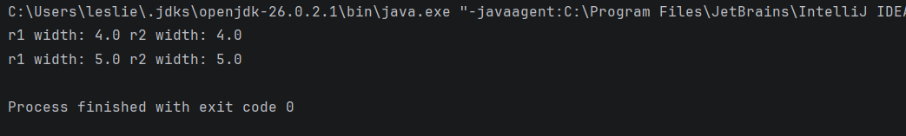

Explanation

When we write Rectangle r2 = r1;, we are NOT creating a new copy of the rectangle. In Java, objects are reference types.r1 holds a reference (address) to the object in memory. r2 = r1 means r2 now holds the same reference/address. Both r1 and r2 point to the same single object in heap memory. So when we change r2.width, we are changing the same object that r1 also points to. Therefore r1.width also changes to 20.This is called shallow copy / reference aliasing. To create a real separate copy, we would need to do Rectangle r2 = new Rectangle(r1.width, r1.height);

- Challenge: Create Address and Person classes where a Person has an Address. Print a person's city using a chained dot expression, and show what happens when the address is null.

Code
public class Address {
String city;
int housenumber;
}

public class Person {
String name;
Address address;
public static void main(String[] args){
// creating the address
Address ad1 = new Address();
ad1.city ="Bulawayo";
ad1.housenumber =9770;
// creating the person
Person me = new Person();
me.name = "Leslie";
// assigning the person'address to the address we have created above
me.address = ad1;
// now its person->address->city
System.out.println(me.name+ "'s address is " + me.address.city);
}
}

output

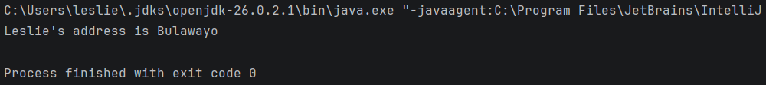

Output when address is null

